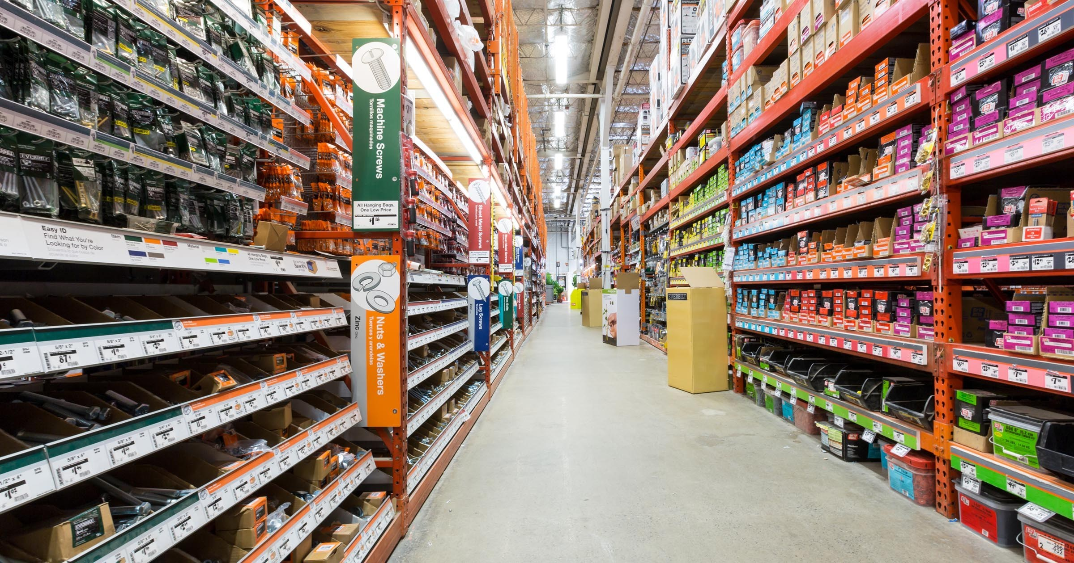

|  |
| --- |
| Advanced Databases |
|  |
| 01/05/2019  Mannion’s Hardware Shop  Authored by: Eugene McCormack Student Number: C17745919 |

# Project Description

For this assignment we are required to develop an application relating to the first phase in the software development process. For this process I choose to base my database application on “Mannion’s Hardware Store” which is a semi fictional hardware store opened in 1973 and is based in Rialto, Dublin with currently only 1 store location.

Mannion’s Hardware Store has recently moved into deliveries and requires an application that can be used throughout all aspects of the business to keep track of their customer information, instore orders, delivery orders, employees and products which they are currently selling. When a customer purchases an item instore or online that requires delivery their details are entered into the “Customer” database. A unique Customer ID number is created for the customer and information relating to the customer is also inputted such as name, contact information and home address. This helps to ensure that the customer can be contacted in case any problems arise with deliveries.

After the customer details have been added to the system an order is created within the “Orders” database relating to the customer delivery. A unique Order ID is created for the customer delivery, the date of the order, shipping / delivery details e.g. shipping address for the order to be delivered, shipped date when the item has been processed, order status, cost of delivery and the employee whom processed the order.

An “Order Details” database is created as to keep track of all current / historical orders for Mannion’s employees and online customers. This database contains a unique Details ID number relating to each purchase the customer made / makes. The following details are added to Order Details database, customer order ID, product ID, quantity the customer ordered, unit amount per item, total amount, shipping fee ID relates to the zone / cost, status ID relating to the delivery status and dispatched date.

When an employee joins the Mannion’s Hardware Store team their details, name, email address, business phone number and job title are added to the “Employee” database system and a unique Employee ID is create for that employee. The employee numbers correspond to any order placed so the company can keep track of whom processed what particular order if any problem arise and also what employee is the most productive by processing the most orders.

Mannion’s deliver to 3 Zones, within the Isle of Ireland “Shipping Fee” cost €5, United Kingdom: €10 and throughout Europe: €15. There are also 6 stages in the in the “Order Status” process, “Pending” – order is entered, “In-Progress” – order is been processed, “Shipped” – order has left the premises, “In-Transit” – order is on route, “Delivered” – order has been received by the customer and “Cancelled” – order cancelled by the customer. These stages help to ensure the customer or company can track the progress of their orders if required.

Finally, when new stock items or an existing item arrive into Mannion’s it’s details can be entered into the “Products” database. A unique Product ID number is create relating to the product and details relating to the item inputted such as product code, name, description (if the item requires any additional details), standard cost (actual cost of goods), retail price (selling price), stock quantity, category (department) and discontinued.

# Entity Relationship Diagram

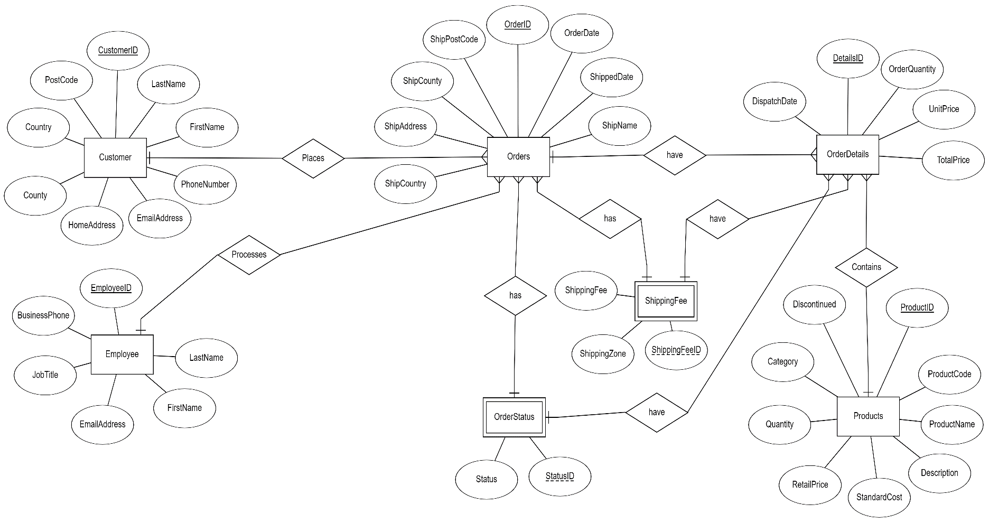

# Relational Model

# 

# SQL Scripts Create Tables

# Create table Customer

# 

# sql = " CREATE TABLE Customer(CustomerID Counter PRIMARY KEY, " + _

# " LastName Text, " + _

# " FirstName Text, " + _

# " PhoneNumber Text, " + _

# " EmailAddress Text, " + _

# " HomeAddress Text, " + _

# " County Text, " + _

# " PostCode Text, " + _

# " Country Text )"

# CurrentDb.Execute (sql)

# Create table OrderStatus

# sql = " CREATE Table OrderStatus (StatusID Counter PRIMARY KEY, " + _

# " Status Text )"

# CurrentDb.Execute (sql)

# 

# Create table ShippingFee

# sql = " CREATE TABLE ShippingFee (ShippingFeeID Counter PRIMARY KEY, " + _

# " ShippingZone Text, " + _

# " ShippingFee Currency )"

# CurrentDb.Execute (sql)

# 

# Create table Employee

# sql = " CREATE TABLE Employee( EmployeeID Counter PRIMARY KEY, " + _

# " LastName Text, " + _

# " FirstName Text, " + _

# " EmailAddress Text, " + _

# " JobTitle Text, " + _

# " BusinessPhone Text )"

# CurrentDb.Execute (sql)

# Create table Orders

# sql = " CREATE TABLE Orders( OrderID Counter PRIMARY KEY, " + _

# " EmployeeID Long REFERENCES Employee(EmployeeID) , " + _

# " CustomerID Long REFERENCES Customer(CustomerID) , " + _

# " OrderDate DateTime, " + _

# " ShippedDate DateTime, " + _

# " ShipName Text, " + _

# " ShipAddress Text, " + _

# " ShipCounty Text, " + _

# " ShipPostCode Text, " + _

# " ShipCountry Text, " + _

# " ShippingFeeID Long REFERENCES ShippingFee(ShippingFeeID) , " + _

# " StatusID Long REFERENCES OrderStatus(StatusID))"

# CurrentDb.Execute (sql)

# 

# 

# Create table Products

# 

# sql = " CREATE TABLE Products( ProductID Counter PRIMARY KEY, " + _

# " ProductCode Text, " + _

# " ProductName Text, " + _

# " Description Text, " + _

# " StandardCost Currency, " + _

# " RetailPrice Currency, " + _

# " Quantity Text, " + _

# " Category Text, " + _

# " Discontinued Text)"

# CurrentDb.Execute (sql)

# 

# Create table OrderDetails

# 

# sql = " CREATE TABLE OrderDetails( DetailsID Counter PRIMARY KEY, " + _

# " OrderID Long REFERENCES Orders(OrderID) , " + _

# " ProductID Long REFERENCES Products(ProductID) , " + _

# " OrderQuantity Short, " + _

# " UnitPrice Currency, " + _

# " TotalPrice Currency, " + _

# " ShippingFeeID Long REFERENCES ShippingFee(ShippingFeeID) , " + _

# " StatusID Long REFERENCES OrderStatus(StatusID) , " + _

# " DispatchDate DateTime )"

# CurrentDb.Execute (sql)

# SQL Scripts Insert Data

# Insert data into Customer Table

# CurrentDb.Execute ("INSERT INTO Customer (LastName, FirstName, PhoneNumber, EmailAddress, HomeAddress, County, PostCode, Country)" + _

# "VALUES('McCormack' , 'Eugene' , '0870546887' , 'eugenemccormack@gmail.com', ' 20 Lower Board', 'Dublin 8', 'D08GH4R', 'Ireland')")

# 

# CurrentDb.Execute ("INSERT INTO Customer (LastName, FirstName, PhoneNumber, EmailAddress, HomeAddress, County, PostCode, Country)" + _

# "VALUES ('McDonnell' , 'Conor' , '0875743345' , 'conormcdonnell@gmail.com', ' 123 Fake Street', 'Liverpool', ' CH449AN ', 'United Kingdom')")

# 

# CurrentDb.Execute ("INSERT INTO Customer (LastName, FirstName, PhoneNumber, EmailAddress, HomeAddress, County, PostCode, Country)" + _

# "VALUES ('Cleary' , 'James' , '0855332987' , 'jamescleary@hotmail.com', ' 10 Fleet Street', 'Dublin 7', 'D07TY9L', 'Ireland')")

# 

# 

# Insert data into Employee Table

# 

# CurrentDb.Execute ("INSERT INTO Employee (LastName, FirstName, EmailAddress, JobTitle, BusinessPhone)" + _

# "VALUES ('Scully' , 'John' , 'johnscully@mannions.ie' , 'Sales Agent', '4549983')")

# 

# CurrentDb.Execute ("INSERT INTO Employee (LastName, FirstName, EmailAddress, JobTitle, BusinessPhone)" + _

# "VALUES ('Neill' , 'Patrick' , 'patrickneill@mannions.ie' , 'Sales Agent', '4549983')")

# 

# CurrentDb.Execute ("INSERT INTO Employee (LastName, FirstName, EmailAddress, JobTitle, BusinessPhone)" + _

# "VALUES ('Cawley' , 'Kieran' , 'kierancawley@mannions.ie' , 'Sales Agent', '4549983')")

# Insert data into ShippingFee Table

# 

# CurrentDb.Execute ("INSERT INTO ShippingFee ( ShippingZone, ShippingFee ) VALUES ('Within ROI', 5.00)")

# 

# CurrentDb.Execute ("INSERT INTO ShippingFee ( ShippingZone, ShippingFee ) VALUES ('UK', 10.00)")

# 

# CurrentDb.Execute ("INSERT INTO ShippingFee ( ShippingZone, ShippingFee ) VALUES ('Europe', 15.00)")

# 

# Insert data into OrderStatus Table

# CurrentDb.Execute ("INSERT INTO OrderStatus(Status) VALUES('Pending') ")

# CurrentDb.Execute ("INSERT INTO OrderStatus(Status) VALUES('In-Progress') ")

# CurrentDb.Execute ("INSERT INTO OrderStatus(Status) VALUES('Shipped') ")

# CurrentDb.Execute ("INSERT INTO OrderStatus(Status) VALUES('In-Transit') ")

# CurrentDb.Execute ("INSERT INTO OrderStatus(Status) VALUES('Delivered') ")

# CurrentDb.Execute ("INSERT INTO OrderStatus(Status) VALUES('Cancelled') ")

# 

# Insert data into Orders Table

# 

# CurrentDb.Execute ("INSERT INTO Orders ( EmployeeID , CustomerID , OrderDate , ShippedDate , ShipName , ShipAddress , ShipCounty , ShipPostCode , ShipCountry , ShippingFeeID , StatusID)" + _

# "VALUES (3 , 1 , '20/04/2019' , '28/04/2019' , 'Eugene McCormack', ' 20 Lower Board', 'Dublin 8', 'D08GH4R', 'Ireland' , 1 , 4)")

# CurrentDb.Execute ("INSERT INTO Orders ( EmployeeID , CustomerID , OrderDate , ShippedDate , ShipName , ShipAddress , ShipCounty , ShipPostCode , ShipCountry , ShippingFeeID , StatusID)" + _

# "VALUES (1 , 2 , '27/04/2019' , '30/04/2019' , 'Conor McDonnell', ' 123 Fake Street ', 'Liverpool', 'CH449AN', 'United Kingdom' , 2 , 3)")

# CurrentDb.Execute ("INSERT INTO Orders ( EmployeeID , CustomerID , OrderDate , ShippedDate , ShipName , ShipAddress , ShipCounty , ShipPostCode , ShipCountry , ShippingFeeID , StatusID)" + _

# "VALUES (2 , 3 , '01/05/2019' , '02/05/2019' , 'James Cleary', ' 10 Fleet Street ', 'Dublin 7', 'D07TY9L', 'Ireland' , 1 , 2)")

# 

# 

# Insert data into Products Table

# CurrentDb.Execute ("INSERT INTO Products ( ProductCode , ProductName , Description , StandardCost , RetailPrice , Quantity , Category , Discontinued)" + _

# "VALUES ('MHSST-63' , 'Tungsten Tip' , '' , '2.00' , '2.75', ' 10 Boxes x 40Bags ', 'Screw', 'No')")

# CurrentDb.Execute ("INSERT INTO Products ( ProductCode , ProductName , Description , StandardCost , RetailPrice , Quantity , Category , Discontinued)" + _

# "VALUES ('MHSHG-105' , 'Glass Hammer' , '' , '14.75' , '19.99', ' 2 Boxes x 20 Hammers ', 'Hammer', 'No')")

# CurrentDb.Execute ("INSERT INTO Products ( ProductCode , ProductName , Description , StandardCost , RetailPrice , Quantity , Category , Discontinued)" + _

# "VALUES ('MHSPV-173' , 'Rustins' , 'Satin Walnut' , '6.65' , '8.50', ' 18 - 250ml ', 'Varnish', 'No')")

# Insert data into OrderDetails Table

# 

# CurrentDb.Execute ("INSERT INTO OrderDetails ( OrderID , ProductID , OrderQuantity , UnitPrice , TotalPrice , ShippingFeeID , StatusID , DispatchDate)" + _

# "VALUES (1, 2, 4, 19.99 , 79.96 , 1 , 4 , '28/04/2019')")

# CurrentDb.Execute ("INSERT INTO OrderDetails ( OrderID , ProductID , OrderQuantity , UnitPrice , TotalPrice , ShippingFeeID , StatusID , DispatchDate)" + _

# "VALUES (2, 1, 7, 2.75 , 19.25 , 2 , 3 , '30/04/2019')")

# CurrentDb.Execute ("INSERT INTO OrderDetails ( OrderID , ProductID , OrderQuantity , UnitPrice , TotalPrice , ShippingFeeID , StatusID , DispatchDate)" + _

# "VALUES (3, 3, 5, 8.50 , 42.50 , 1 , 2 , '02/05/2019')")

|  |
| --- |
|  |
|  |
|  |